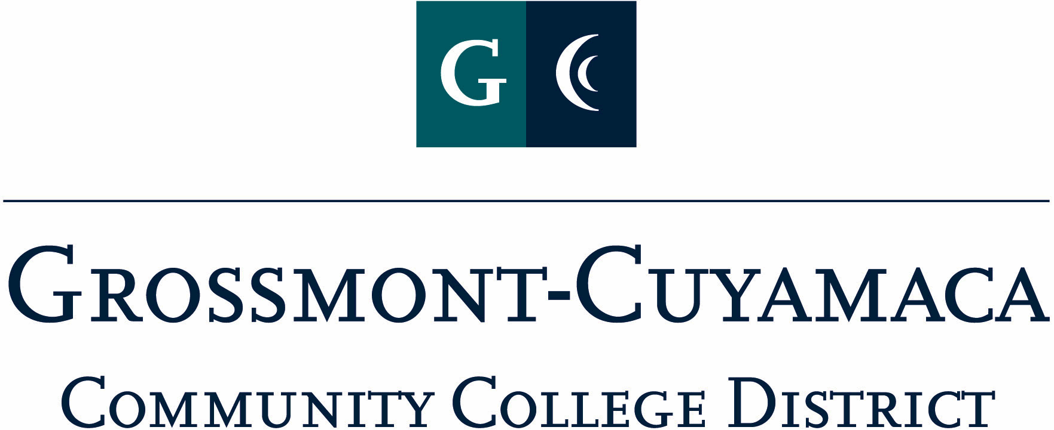
CLASSIFIED SENATE
EXECUTIVE BOARD MEETING
April 5, 2011– Meeting Minutes

Members Present: Debi Miller, Paula Tillery, Maggie Gonzales, Avelina Miller, Wendy Corbin, Yvette Macy, Maria Briney, Angela Johnson, Scott Howell, pat Murray, jean Wallace, Rocky Rose
Members Absent: Patricia Bailey, JacQueline Osborne, Karen Ostegard, Karen McCoy, Joe Balistreri
Members Excused: Lynne Davidson, Monica Farris

1. Welcome and Call to Order

The meeting was called to order at 12:05p.

2. Approval of Minutes from March 1, 2011

The minutes from March 1, 2011 meeting were approved. M/S/A Rose/Johnson.

3. Continuing Business. President Debi Miller went over the last minute details with the group. (1) the registration has gone out and can register online; (2) Maria Briney and Scott Howell are working on the signage for the campus and Debi Miller will ask facilities to drop off sandwich/cement can signs to the Student Center; (3) the President asked if there was interest by any other Board members to Emcee the event, Yvette Macy said she would not mind doing it; (4) the nomination form had gone out electronically to the sites and forms will be available at the registration table during Classified Staff Appreciation Day.

4. Communication.

VP Reports

Grossmont: Pat Murray, Vice President, reported that Grossmont College is conducting a Leadership Retreat on April 29th. All GC Council officers were invited to attend. The goal is to identify college priorities based on data and strategic plan. The Institutional Excellence committee is working on a Key Performance indicating grid that will help identify areas that need improvement. Anyone that attends the Leadership Retreat and would like to serve on the Institutional Excellence committee, please contact me. The group meets monthly on Fridays at 11a.

The instructional deans area is still undergoing different scenario exploration. A six-dean model is favored to distribute workload. This would split the Sr. Dean position and eliminate one associate dean. All employees have been assured that they would not lose their jobs.

The GC Commencement will still be held on our campus despite the construction. Pipe and Drape will be set in front of the admin quad and it will be business as usual. Will Pines has stepped forward to represent staff in the reading of graduate names.

The college-wide professional development committee is evaluating other college models in the hope of reconstituting staff development for all constituents.

The budget Plan B is being strategized across the board. Our summer programs will not be cut another 25% (and that is on top of the 50% from last summer). All departments have been asked to cut FTEF another 3% to the meet the budget crisis.

District: Wendy Corbin, Vice President, reported on the following:
- DEC: she attended DEC which looks at the docket items for the upcoming board meeting. Due to unanticipated scheduling at Grossmont, the Board meeting for April will be held at Cuyamaca, and the May meeting will be at Grossmont.
  - BP1710: was brought before the group, they are reworking
  - AP3300: the group will be reworking
- District Services Reorganization: the submittal included the elimination of the Vice Chancellor positions, and other positions to be added and to be promoted. The titles, organization chart and specifics were not presented
- Total Compensation Study: moving forward and aligning
- Planning & Budget Jam: held two workshops highlighting emergency preparation, Microsoft update and EEOC update
- Benefits: HIPPA training being offered
- District Services Star Awards: the district will work collaborative on quarterly awards. Any employee, vendor, administrator can be included. The theme of “Starbursts” will be used and include a lapel pin. District Classified Senate has committed to facilitating the distribution of the award
- District Safety: APD Compliance and oversight by Joel Javines. AEDs will be brought into compliance. Working on permits and procedures for vehicles on campus.
- Safety: checking crosswalks for appropriate designation

Cuyamaca: Maggie Gonzales, Vice President, reported:
- IPC: met on March 22nd.
- Accreditation Steering Committee: the faculty co-chair is Tammi Marshall and now includes classified on the 4 standards as chairs
- Academic Planning & Institutional Effectiveness (AP&IE) Task Force: looking at integrated planning an establishing a model for the college
- Education Master Plan: the invite to be on a Scan Team has gone out
- Classified Staffing Task Force: will be presenting at the next IPC meeting
- Professional Development Committee: having conversation about flex time and developing a way for classified to be compensated for their service on committees

The members discussed some matters concerning Education Master Plan and the flex time option for classified.

President’s Report: Debi Miller, President, reported:
- Retreat: the 9/23 date for the Retreat was not available at Mission Trails Regional Park, and the next available date was 9/16. She reserved that date for the Retreat.
- CSAD Debrief meeting: she wanted to schedule a debrief meeting as soon as possible after the event. An April 28th date was agreed to by the group.

Treasurer Report: Paula Tillery, Treasurer, reported that there was $3,619.09 in the CS Trust and $2,878.00 in the CSAD account. Pat Murray will be working with Paula Tillery on the PRs and POs associated with CSAD.

5. Fundraising Activities: Since the cookbook fundraiser was successful, the group would like to consider doing another one. Debi Miller suggested that this item be tabled for a possible discussion topic at the Retreat. Since there are still some cookbooks left over from the fundraiser, 4 of them will included w/the Marie Calendar pie coupons as raffle prizes for CSAD.

6. Governance:

- Classified Staff Development Committee: Wendy Corbin explained the subject-matter threads that were established in response to the survey that went out to classified. The three threads are: Technology, Knowing your District and Wellness. Classified will be able to get credit for the threads during CSAD. The committee is also establishing other dates for workshops to be offered to classified prior to the 4-10 schedule.
- Classified Staffing Task Force: The request form and rubric was presented for a 1st read. Any comments, concerns or edits should be forward to Debi Miller, and then presented at the next meeting for a 2nd Read/Final Approval.

7. New Business: Nothing brought forward.

The meeting adjourned at 12:59p.

